**ECEN452: ULTRA HIGH FREQUENCY TECHNIQUE**

**LAB06**

**SAMBONG JANG**

**DR. HUFF**

**Task 1: Synthesis and implementation of a maximally-flat low-pass filter.**

**GIVEN:**

Characteristic Impedance = 50 ohm

Thickness of substrate = 62 mil = 1.5748 mm

Dielectric constant of substrate = 4.1

Loss tangent of substrate = 0.01

Center Frequency = 2.5GHz

Minimum attenuation of 10dB at 3.25GHz

**Background:**

The insertion loss allows a high degree of control over the passband and stopband amplitude and the phase characteristics, with a systematic way to synthesize a desired response. Chebyshev response would satisfy a requirement for the sharpest cutoff. Chebyshev polynomials are useful in approximation. Maximally-flat is a characteristic that is also known as the binomial or Butterworth response, and is optimum in the sense that it provides the flattest possible point in the passband response for a given filter complexity, or order.

Load resistance will be normalized as 1 in maximally flat case whereas non-unity load resistance will be presented in equi-ripple filters with even N order.

**The power loss ratio is given:**



Now, we obtain the power loss ratio expression for the maximally flat response:



**Calculation:**

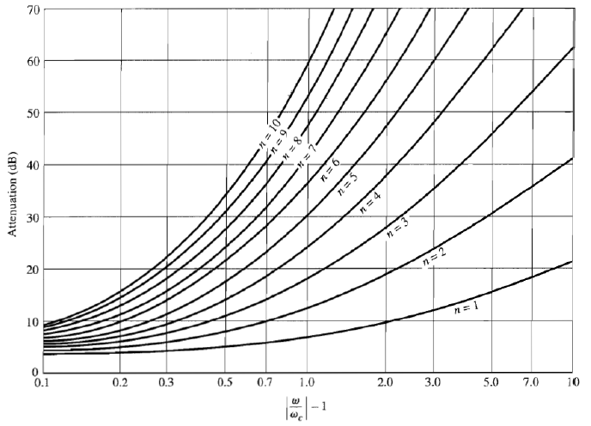

Figure. Attenuation [dB] in terms of frequency

$$\left|\frac{ω}{ω_{c}}\right|-1=\left|\frac{f_{10dB}}{f_{c}}\right|-1=0.3$$

It seems N=4 curve doesn’t really meet the point so we need the above curve (about 11dB, which is better) N=5 curve will do fine.

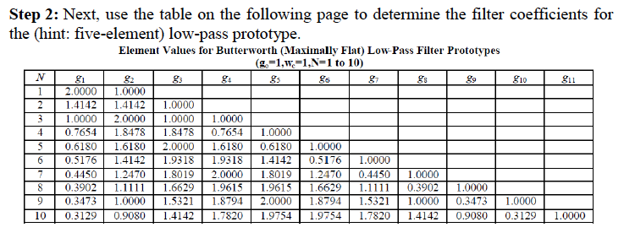

Figure

For $N=5$,

$$g_{1}=0.6180$$

$$g_{2}=1.6180$$

$$g_{3}=2.0000$$

$$g_{4}=1.6180$$

$$g_{5}=0.6180$$

$$g_{6}=1.0000$$

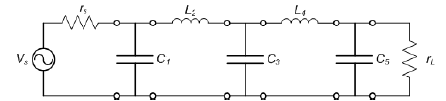

Figure

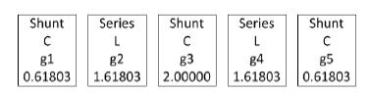

Figure

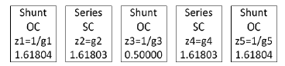

Figure

Note that these values are normalized with the reference impedance $Z_{0}$

What we aim here is that we want to make all the elements in shunt; however, it requires multi-steps of calculations to achieve. The idea here is that we just add unit element and use it as a tool used in Kuroda’s identity. After a couple of steps, we will be ended up with all elements in shunt.

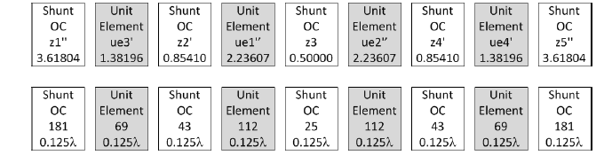

Figure

Width of UE1 = 1.761mm (69 ohm)

Length of UE1 = 8.633mm

Width of UE2 = 0.541mm (112 ohm)

Length of UE2 = 8.892mm

Width of 181 ohm = 0.0858mm

Length of 181 ohm = 9.076mm

Width of 43 ohm = 3.964mm

Length of 43 ohm = 8.349mm

Width of 25 ohm = 8.398mm

Length of 25 ohm = 8.042mm

Width of 50 ohm = 3.130mm



Figure

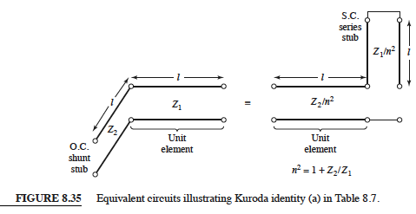

Figure

Kuroda Identities are used for converting series stubs to shunt stubs whereas Richards Transformation is used for transforming capacitors to open stubs and inductors to short stubs. This is huge advantage because it allows some variation in design.

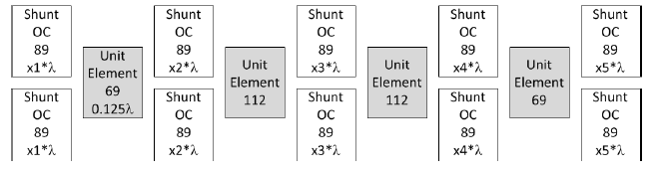

Figure. The final circuit after transformation

The input impedance of open circuit stub is given by:

$$Z_{OC}=-jZ_{0}cot(βl)$$

for $\frac{λ}{8} line, Z_{OC}=-jZ_{0}$

since we are interested in easier implementation in practice, we fix the width of stub as 1mm, which corresponds to

$$Z_{0}= 89Ω$$

and the above figure shows 89 ohm stubs are in parallel with that being said,

$$Z_{OC}=Z_{0}||Z_{0}cot⁡(\frac{2πx_{n}}{λ})$$

also we know the following relation

$$\cot^{-1}\left(y\right)=\frac{π}{2}-\tan^{-1}\left(y\right) for any y$$

hence,

$$x_{1}=x_{5}=0.038368λ=2.694mm$$

$$x_{2}=x_{4}=0.12773λ=8.968mm$$

$$x_{3}=0.168536λ=11.833mm$$

with $λ=70.212mm$

Now, unit element calculations:

Width of UE1 = 1.761mm (69 ohm)

Width of UE2 = 0.541mm (112 ohm)

Length of UE1 = 8.633mm (69 ohm)

Length of UE2 = 8.892mm (112 ohm)

Width of 50 ohm = 3.13mm

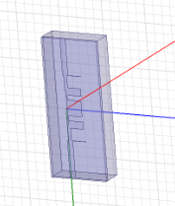

Figure. MaxFlat T line

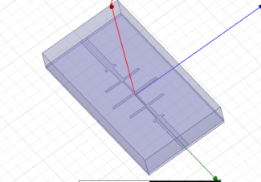

Figure. MaxFlat Tapped

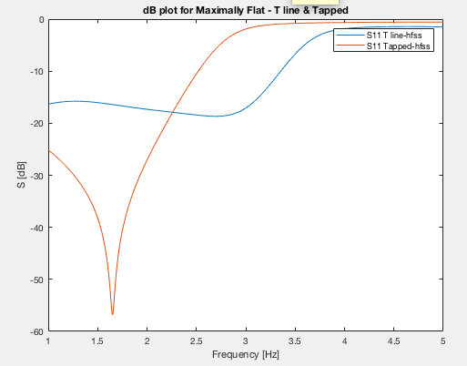

Figure

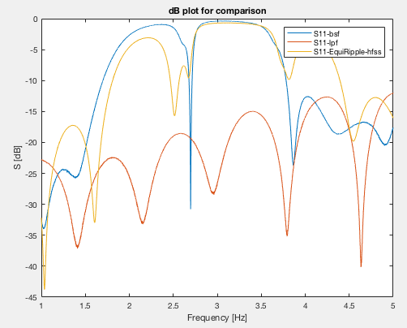

Figure

The band stop filter with range between approximately 2.7GHz and 3.9GHz

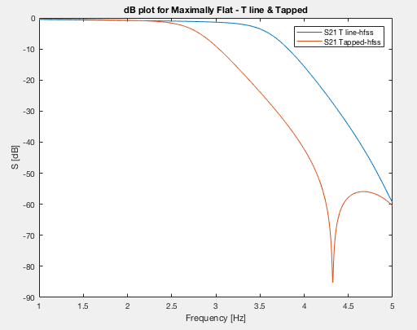

Figure

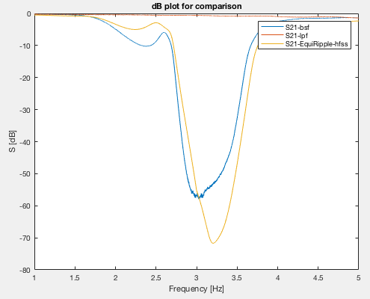

Figure

HFSS design for Equi-Ripple shows around -60dB at the center frequency.

**Task 2: Synthesis and implementation of an Equi-ripple band-stop filter.**

**Given:**

Center Frequency = 3 GHz

Bandwidth of 2.25 GHz to 3.75 GHz

Microstrip line

Characteristic Impedance = 50 ohm

Thickness of substrate = 62 mil = 1.5748 mm

Dielectric Constant = 4.1

Loss Tangent = 0.01

**Background:**

If a Chebyshev polynomial is used to find the insertion loss of an Nth order low-pass filter,



then a sharper cutoff will result, although the passband will have ripples of amplitude, $1+k^{2}$, since $T_{N}\left(x\right)$ oscillates between $±1 for x^{2}$. ( $T_{N}\left(x\right)$ is the Chebyshev polynomial of N th order)

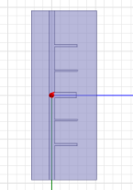

Figure. EquiRipple



Figure – Table 8.4

In order to determine ‘N’ for design, we need to know the ripple level and the following figure can help the determination.



Figure

$$g_{1}=1.7058$$

$$g_{2}=1.2296$$

$$g_{3}=2.5408$$

$$g_{4}=1.2296$$

$$g_{5}=1.7058$$

$$g_{6}=1.0000$$

Scaled Impedance values of the equivalent open-circuit stubs using the following equation:

$$Z_{s}=\frac{4Z_{0}}{πg_{n}Δ}$$

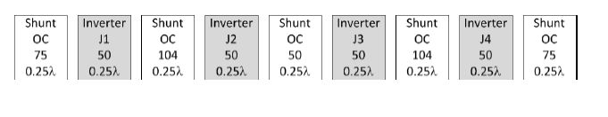

Figure

Length of 75 ohm = 14.446mm

Width of 75 ohm = 1.479mm

Length of 104 ohm = 14.743mm

Width of 104 ohm = 0.6685mm

Length of 50 ohm = 14.033mm

Width of 50 ohm = 3.117mm

length of UE = 14.033mm

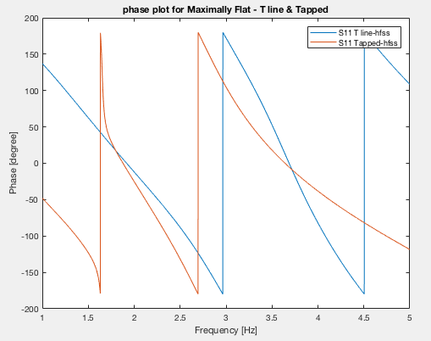

Figure

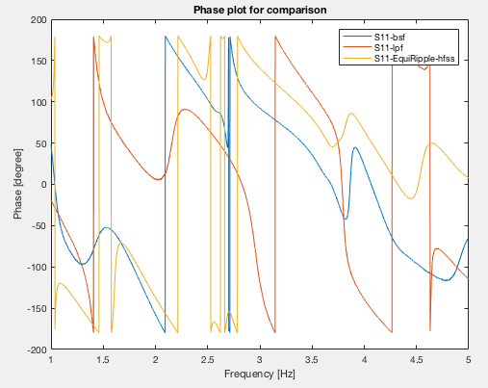

Figure

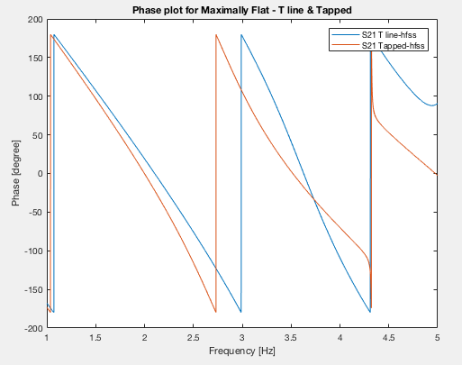

Figure

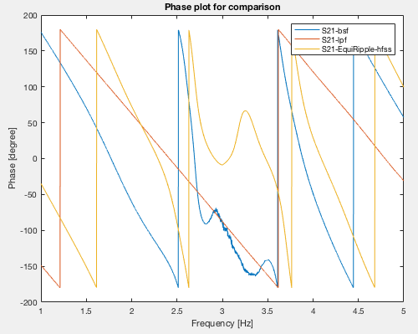

Figure

**References:**

[1] Microwave Engineering 4th Edition, David M. Pozar